27.16: a) 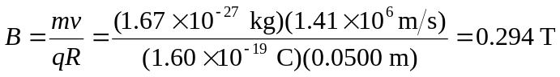
The direction of the magnetic field is out of the page (the charge is positive).
b) The time to complete half a circle is unchanged:
